

* Outlier: 2756.954, community area 37
* Fuller Park, only 2876 population (does not take a lot of criminal acts to boost their violent crime index)
* <https://news.wttw.com/2015/11/18/fuller-park-small-community-big-problems>

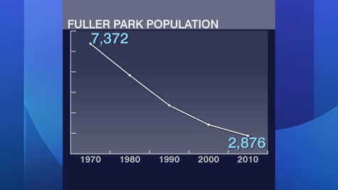

* Fits our calculation – top 2 fuller park and Washington park

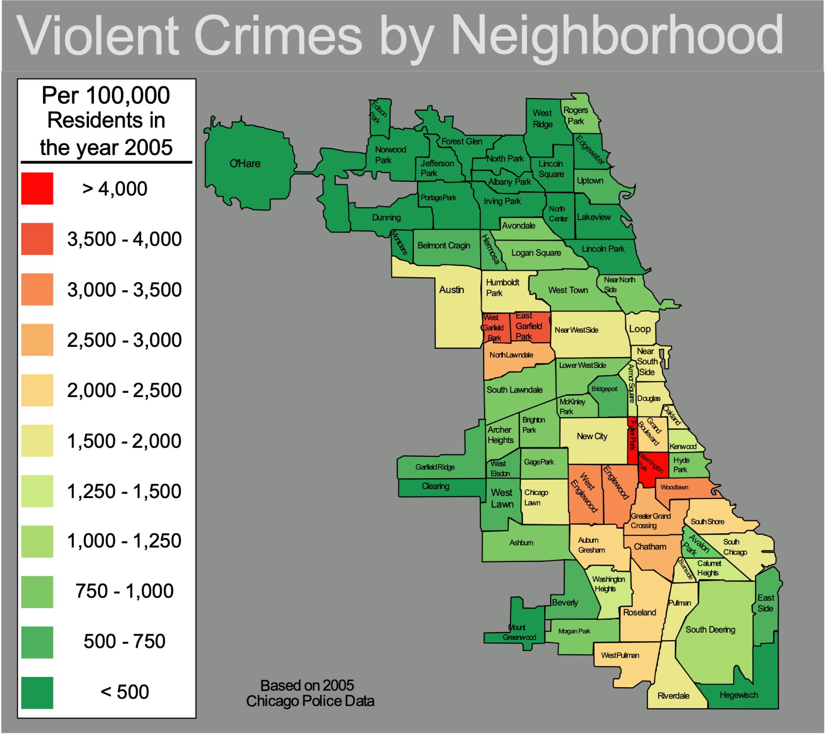





* 2 outliers:
* higher: 1, community 57
* lower: 0.9586, community 45





* several overlapped outliers:
* Community 3: 4 hospitals
* Community 4: 3 hospitals
* Community 24: 3 hospitals
* Community 28: 4 hospitals



* 50% of the communities have 40 – 60 teen moms among every 1000 female teenagers, which is 4% - 6%
* Number goes up to 120 per 1000 female teenagers, which is 12%



* 1 outlier: 22.6, community 37









* Over 50% of the communities only have 0 – 10% of Asian
* Extreme outliers: 49%, community 34,

32%, community 60



